# Lab - 4

**One-Sample T test**

**Descriptive Statistics**

|  |  |  |  |  |
| --- | --- | --- | --- | --- |
| **N** | **Mean** | **StDev** | **SE Mean** | **95% CI for μ** |
| 50 | 49.620 | 6.577 | 0.930 | (47.751, 51.489) |

μ: population mean of weight

**Test**

Null hypothesis H₀: μ = 50

Alternative hypothesis H₁: μ ≠ 50

|  |  |
| --- | --- |
| **T-Value** | **P-Value** |
| -0.41 | 0.685 |

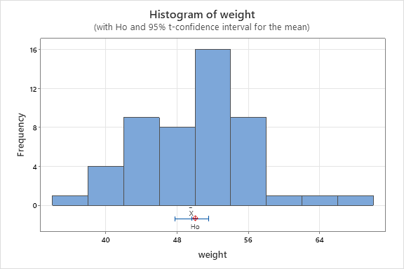

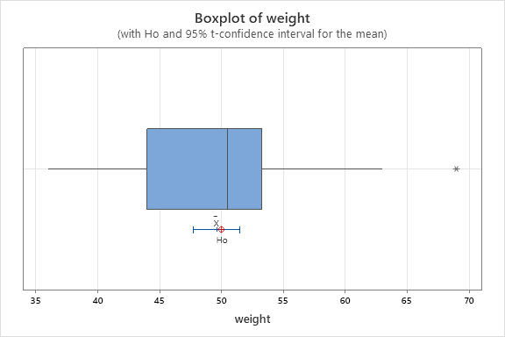**Conclusion**

The graph of box and whisker plot and histogram shows that the data is left skewed i.e. not normally distributed. Hence, t - test for mean is not valid test for population mean because it violates the fundamental assumptions that the data is normally distributed. The alternative test could be Wilcoxon signed rank test or sign test.

Further p-value = 0.685 > α – value = 0.05, we accept the null hypothesis that the mean weight of metal ring is 50 ounces. The 95% confidence interval for population mean (µ) is 47.75 ounces to 51.49 ounces.

# Lab - 5

**Two-Sample T-Test and CI: New Machine, Old Machine**

**Method**

μ1 =Mean of New Machine

μ2 = Mean of Old Machine

Difference = μ1- μ2

Equal variances are assumed for this analysis.

**Descriptive Statistics**

|  |  |  |  |  |
| --- | --- | --- | --- | --- |
| **Sample** | **N** | **Mean** | **StDev** | **SE Mean** |
| **New Machine** | 10 | 42.140 | 0.683 | 0.22 |
| **Old Machine** | 10 | 43.230 | 0.750 | 0.24 |

**Estimation for Difference**

|  |  |  |
| --- | --- | --- |
| **Difference** | **Pooled StDev** | **95% Upper Bound for Difference** |
| -1.090 | 0.717 | -0.534 |

**Test**

Null hypothesis H₀: μ1- μ2 = 0

Alternative hypothesis H₁: μ1- μ2 < 0

|  |  |  |
| --- | --- | --- |
| **T-Value** | **DF** | **P-Value** |
| -3.40 | 18 | 0.002 |



**Conclusion**

The box plot clearly shows that the new machine has significantly lower meaning than that of the old machine. The shape of the new machine is symmetrical while the shape of the old machine is slightly left skewed. but the variation of packing time for both machines is the same. Hence the two machines are the same in terms of process standard deviation, but they are different in terms of average processing time.

Since p - value << α - value = 0.05, we strongly reject the null hypothesis that the average packaging time is same and hence conclude that packaging time is significant difference. Comparing the average packaging of a new machine (42.14) and that of a new machine (43.23), the new machine packs significantly faster than the old machine. hence new machine is superior to old machine